MICHAEL OMOTUYI 23152483
THIS 1ST SS IS THE LOG IN DEMONSTRATION ON HOW IT WILL RUN

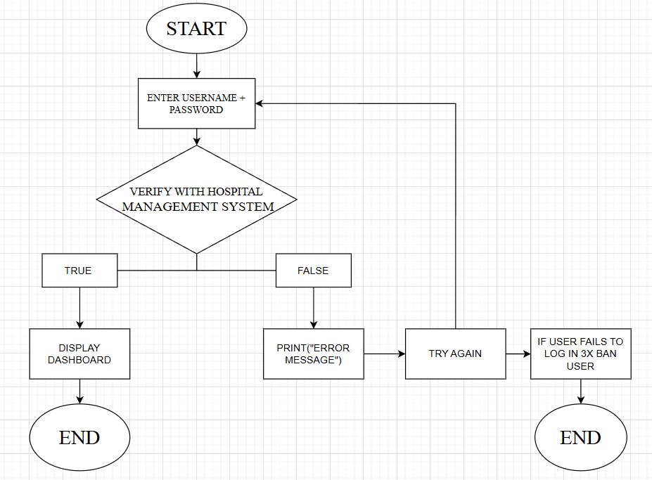
THIS 2ND SS IS THE APPOINTMENTS ON HOW I WILL RUN IT ON THE CODE THIS IS DEMONSTRATION …?
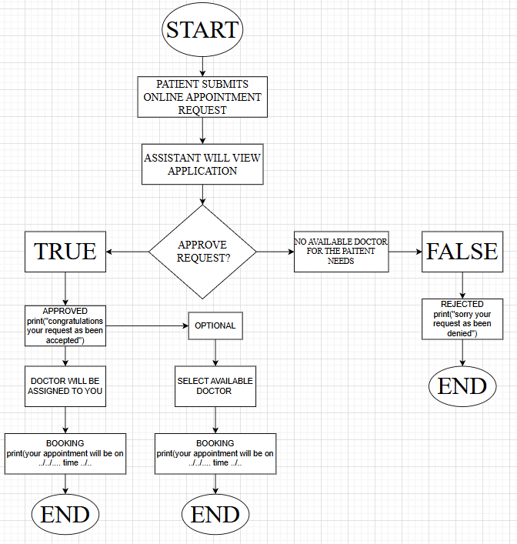
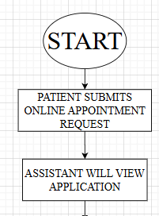 The is just the beginning of the appointment process
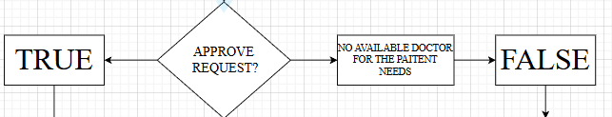This is the YES or NO
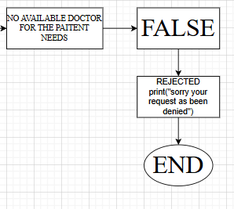 IF NO
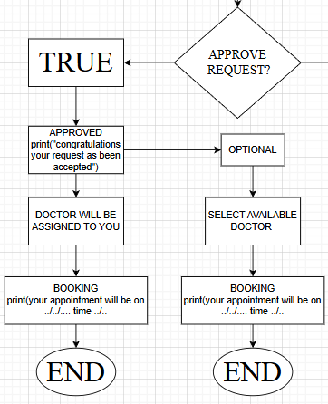 IF YES

